**M S Ramaiah Institute of Technology**

(An Autonomous Institute, Affiliated to VTU)

MSR nagar, MSRIT post, Bangalore-54

A Dissertation Report on

**Wireless Temperature Monitoring System using RaspberryPi2**

Submitted by

Sanjana K.S 1MS12CS098

Vidit Jain 1MS12CS127

Vignesh P 1MS12CS128

Vishal H 1MS12CS132

*In partial fulfillment for the award of the degree of*

# *Bachelor of Engineering in Computer Science & Engineering*



**DEPARTMENT OF COMPUTER SCIENCE & ENGINEERING**

**M.S.RAMAIAH INSTITUTE OF TECHNOLOGY**

**(Autonomous Institute, Affiliated to VTU)**

**BANGALORE-560054**

[www.msrit.edu](http://www.msrit.edu), **May 2015**

#### Contents

***Declaration i***

***Acknowledgements ii***

***Abstract iii***

***List of Figures***

1 **INTRODUCTION 7**

* 1. General Introduction
  2. Statement of the Problem.
  3. Objectives of the project
  4. Project deliverables
  5. Current Scope
  6. Future Scope.

1. **PROJECT ORGANIZATION 13**
   1. Software Process Models
   2. Roles and Responsibilities
2. **LITERATURE SURVEY 16**

3.1 Introduction

3.2 Main Body

3.3 Conclusion of Survey

1. **SOFTWARE REQUIREMENT SPECIFICATIONS 19**

4.1 Product Overview

4.2 External Interface Requirements

4.2.1 User Interfaces

4.2.2 Hardware Interfaces

4.2.3 Software Interfaces

4.2.4 Communication Interfaces

4.3 Functional Requirements

4.3.1 Functional Requirement 1.1

:

4.3.n Functional Requirement 1.n

4.4 Software System Attributes

4.4.1 Reliability

4.4.2 Availability

4.4.3 Security

4.4.4 Portability

4.4.5 Maintainability

4.4.6 Performance

4.5 Performance Requirements

4.6 Database Requirement

4.7 Design Constraints

4.8 Other Requirements

1. **DESIGN 26**
   1. Introduction
   2. Architecture Design
   3. Graphical User Interface
   4. Class Diagram and Classes (represent Inheritance, Aggregation and Association)
   5. Sequence Diagram
   6. Data flow diagram
   7. Metric calculation
2. **IMPLEMENTATION 39**
   1. Tools Introduction
   2. Technology Introduction
   3. Overall view of the project in terms of implementation
   4. Explanation of Algorithm and how it is been implemented
   5. Information about the implementation of Modules
3. **TESTING 47**

**7.1** Results and Snapshots

1. **CONCLUSION & SCOPE FOR FUTURE WORK 53**
2. **REFERENCES 54**

**DECLARATION**

We hereby declare that the project entitled “**Wireless Temperature Monitoring System using Raspberry Pi2**” which is submitted for the subject "**Project Based Learning**" is our original work and the project has formed the basis in thepartial fulfillment for the award of the degree of Bachelor of Engineering in Computer Science & Engineering

Signature of the Students:

Place:

Date:

**ACKNOWLEDGEMENT**

First and foremost we would like to thank Mrs. Sowmya B. J, Assistant Professor, Department of Computer Science and Engineering, M. S. Ramaiah Institute of technology, Bangalore, who was also our supervisor, for their consistent guidance on each and every step of our project and our HOD Dr. K.G.Srinivasa, Professor. Also we show our gratitude to all the teaching and non teaching staff of Computer science engineering, M.S Ramaiah Institute of technology. Without their push and motivation, this project would have not been completed. Their continuous support and help made this project feasible. Without their support we would not have been able to excel in our project. Lastly, we would like to thanks all our friends and teammates for believing in each other and our capabilities.

# ABSTRACT

This project deals with design and implementation of Wireless Temperature Monitoring System using Raspberry pi2, DS18B20 temperature sensors, and Raspberry pi camera module. This system is essential in both industries as well as in homes to remotely monitor the temperature and constantly update it to the open source cloud named PrivateEyePi which provides relatively simple cloud interfacing and data analysis for Raspberry pi projects. The proposed system reads the temperature value of the surroundings and updates it to the cloud continuously and sends Gmail alerts along with a picture of the place using SMTP protocol only if the temperature exceeds the user defined threshold temperature value. Raspberry pi is connected to a Wi-Fi network using Tenda Wireless Wi-Fi adapter. Thus internet connectivity is required to perform the operations described above. Also the temperature values are entered into a database for providing persistent offline storage. A preexisting Android application called RaspiCheck has been configured to display the temperature values that are read by the sensors. Thus the aim of the project is to remotely measure the inside and outside home temperature using RaspberryPi2.

**LIST OF FIGURES**

|  |  |  |
| --- | --- | --- |
| **Figure No.** | **Description** | **Page No.** |
| 1 | Raspberry Pi2 | 9 |
| 2 | General Interfaces | 9 |
| 3 | GPIO Pin out diagram | 10 |
| 4 | Project Timeline | 12 |
| 5 | Pictorial Representation of Algorithm | 28 |
| 6 | System Design | 29 |
| 7 | Web GUI | 30 |
| 8 | IOS GUI | 31 |
| 9 | Android GUI | 32 |
| 10 | Class Diagram | 33 |
| 11 | Sequence Diagram for Remote Access | 34 |
| 12 | Sequence Diagram for Data Access | 35 |
| 13 | Sequence Diagram for Cloud Login | 35 |
| 14 | Sequence Diagram for Working | 36 |
| 15 | Sequence Diagram for Gmail Login | 36 |
| 16 | Data Flow Model | 37 |
| 17 | Tools Required | 40 |
| 18 | Flowchart | 43 |
| 19 | Algorithm Description | 44 |
| 20 | Terminal Access | 51 |
| 21 | Angry IP scanner and Putty | 52 |
| 22 | VNC viewer | 52 |
| 23 | Database access | 53 |
| 24 | Console | 53 |
| 25 | Gmail Alerts | 54 |
| 26 | Cloud Login | 54 |
| 27 | Cloud Access screen | 56 |
| 28 | Inside room temperature calendar | 56 |
| 29 | Outside room temperature calendar | 56 |

1. **INTRODUCTION**
   1. **GENERAL INTRODUCTION**

The Raspberry Pi is a series of credit card–sized single-board computers developed in the UK by the Raspberry Pi Foundation with the intention of promoting the teaching of basic computer science in schools.Raspberrypi2 uses the Broadcom BCM2836 as the Soc which contains a quad-core ARM Cortex-a7 processor with floating point & NEON, running at 900MHz and a Video core 4 GPU. The GPU is capable of Blu-Ray-quality playback, using H.264 at 40MBits/s. It has 1 GB of RAM and 4 USB 2.0 ports and one micro USB for 5v power supply. It has HDMI video output and persistent storage is provided by the micro SD card that can be inserted into its respective slot. It is a portable little computer which can be used in electronic projects, and for many of the things that your desktop PC does, like spreadsheets, word-processing and games. It has an IEEE 802.5 standard Ethernet card and also MAC – Media Access Control which is being controlled by a chip called as the ASIC – Application Specific Integrated Circuit. Internet communication is possible with the help of Ethernet card at approximately 100MB/s.

The Raspberry Pi hardware has evolved through several versions that feature variations in memory capacity, and peripheral device support.

This block diagram depicts models *A*, *B*, *A+*, and *B+*. Model *A* and *A+* and *Zero* lack the Ethernet and USB hub components. The Ethernet adapter is connected to an additional USB port. In model *A* and *A+* the USB port is connected directly to the SoC. On model *B+* the chip contains a five-point USB hub, of which four ports are available, while model *B* only provides two. On the model *Zero*, the USB port is also connected directly to the SoC, but it uses a micro USB (OTG) port.

DS18B20 sensors are used in this project. This semiconductor temperature sensor offers high accuracy and high linearity over an operating range of about 55 degree centigrade to 150 degree centigrade. It is an integrated circuit, and can therefore include extensive signal processing circuitry within the same package as the sensor thus eliminating additional circuitries. This sensor can be directly connected to the Raspberry pi’s GPIO pin and thus capable of direct and reliable communication with it. Other features are that it’s lightweight and has a wide power supply range (2.7 V to 5.5 V) and converts the temperature to a digital value in less than 1s.

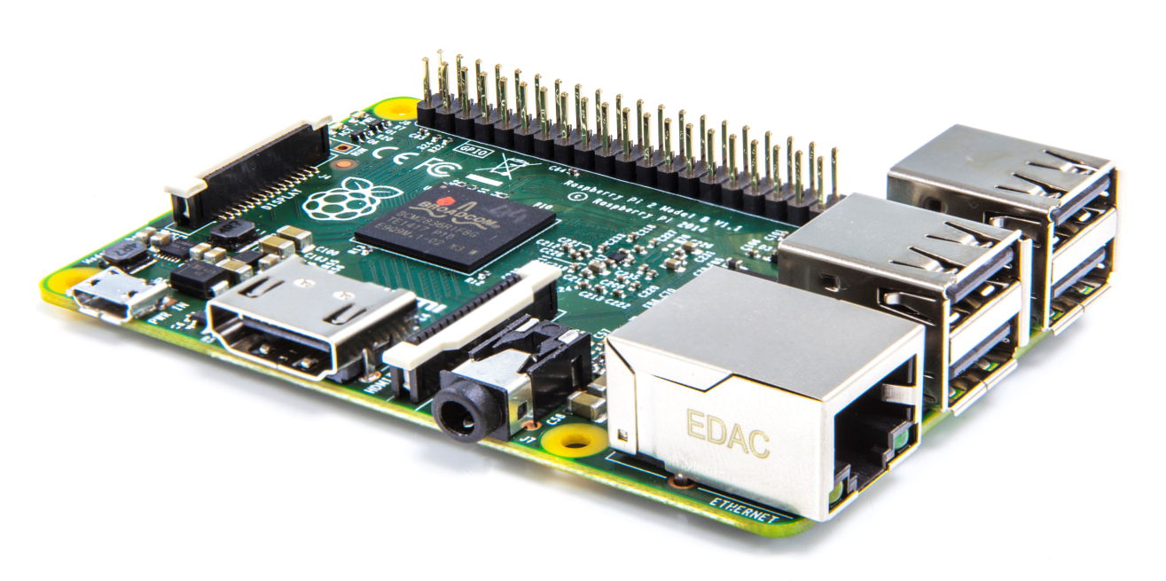

**Figure 1** Raspberry Pi2

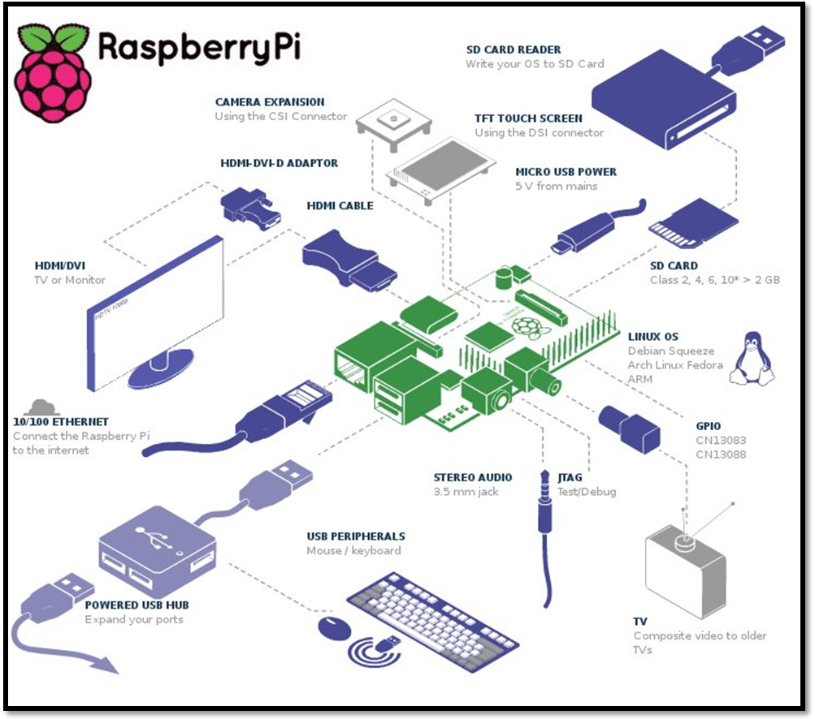

**Figure 2** General Interfaces

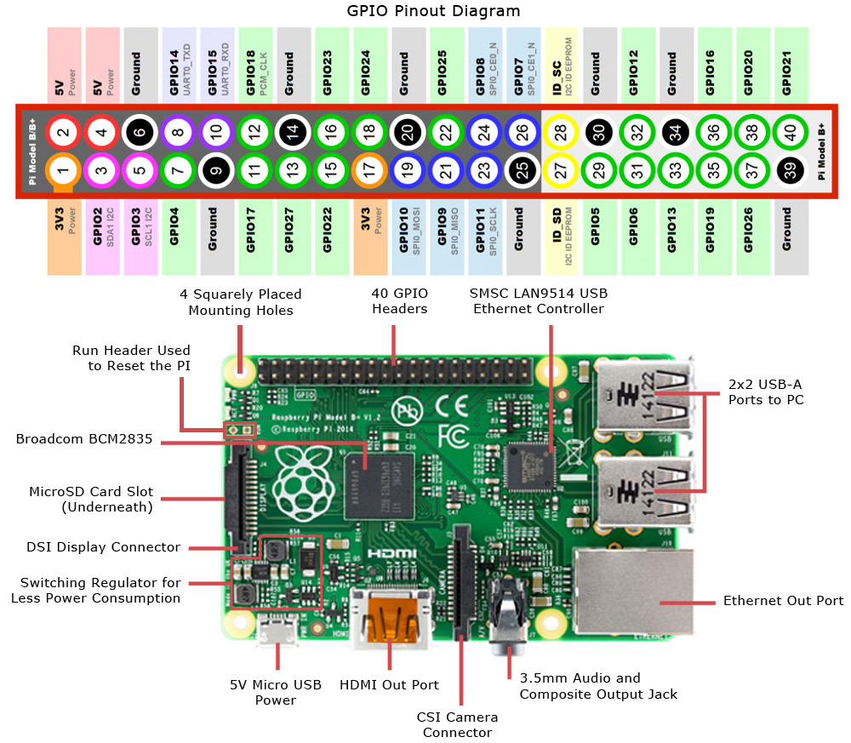

**Figure 3** GPIO Pin out diagram

* 1. **PROBLEM STATEMENT**

Wireless Temperature Monitoring System: The aim of this project is to remotely measure the inside and outside room temperature using Raspberrypi2. We have used two DS18B20 sensors to measure the real time temperature and update it in the open source cloud and in the database. The temperatures are constantly monitored and printed on the console. Also an email alert with a photo of the surroundings is sent to the intended recipient if the inside room temperature exceeds a certain predefined limit.

* 1. **OBJECTIVES OF THE PROJECT**

1. Remotely measure the inside and outside room temperature.
   * This is done by using Putty and VNC Viewer with the help of DS18B20 sensors
2. Send a Gmail alert when the temperature exceeds the threshold value.
   * Achieved using python code and SMTP.
3. Take a picture of the surroundings when the temperature exceeds the threshold value and send it along with the Email.
   * Achieved using python code and Raspberry Pi camera module
4. Update the temperature values in an open source cloud access it from anywhere.
   * PrivateEyePi is the open source cloud used for this purpose.
5. A mobile application to check the temperature value
   * RaspiCheck is used for this purpose.
6. Providing persistent offline storage of temperature readings.
   * Database in MySQL is created for this purpose.
   1. **PROJECT DELIVERABLES**
7. Temperature Measurement is achieved by parsing the raw data and extracting the actual temperature values.
8. Remote Temperature measurement module: This deliverable is intended to remotely access the temperature values that are measured by the DS18B20 sensors. This is achieved by making sure that laptop is connected to a Wi-Fi network and this network is shared over the LAN cable connected between the laptop and raspberry pi.
9. Sending Gmail Alerts along with a picture of the surroundings when the inside room temperature exceeds the user defined value is another important deliverable of the project.
10. Constantly updating the temperature values to the cloud is the most important deliverable with respect to this project and it needs to be spontaneous in nature as the cloud website must reflect the real time temperature values.
11. An android mobile application is configured and used to remotely access the temperature values measured by the sensors from the mobile phone.
12. Persistent offline storage is provided by using MySQL database.

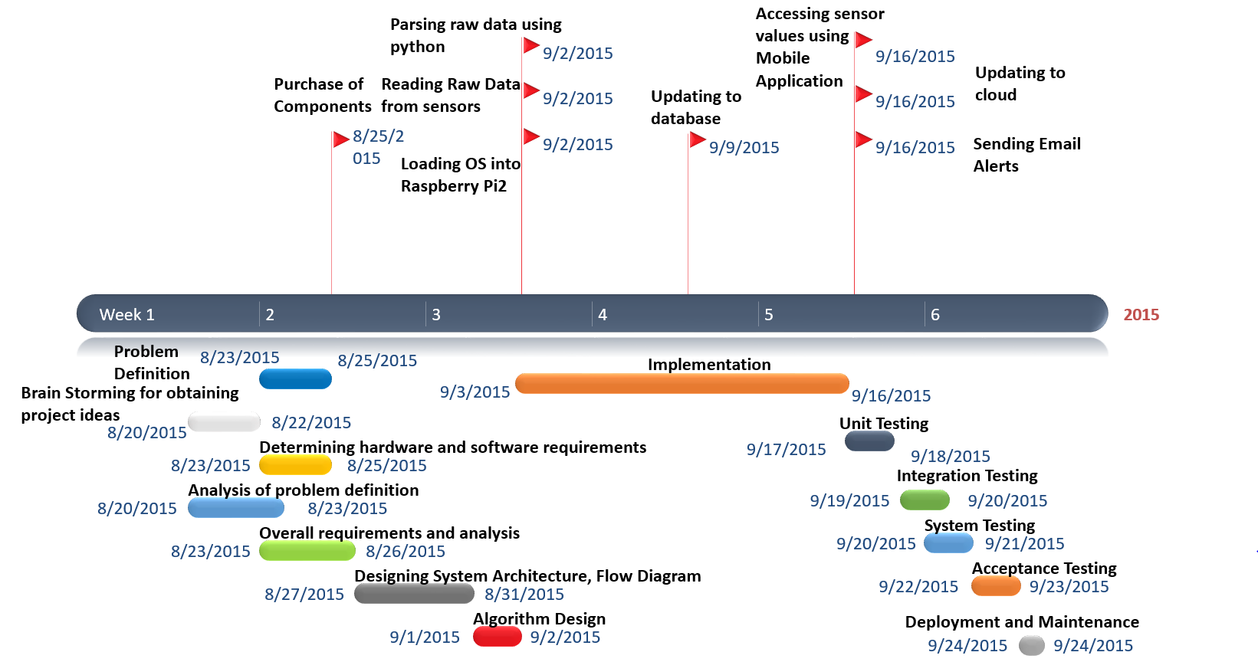

**Figure 4** Project Timeline

* 1. **CURRENT SCOPE**

The project deliverables are achieved by using various applications and python code. The temperature values are measured using DS18B20 sensors and it’s remotely accessed using Putty and VNC viewer and angry IP scanner. Angry IP scanner gives the list of IP addresses of the devices that are connected to a given Wi-Fi network from which the IP address of the raspberry pi is obtained and this is entered into Putty to remotely access the terminal of Raspbian OS. In order to provide total access to the Raspbian OS VNC viewer is used. Later python code is used to parse the raw data and extract the actual temperature and to send Gmail alerts along with pictures. MySQL is used for the backend database configurations.

* 1. **FUTURE SCOPE**

Mobile notifications and Amazon Web Services’ SNS (Simple notification service) have to be integrated to the wireless temperature monitoring system in order to have a much broader scope and range in terms of the notifications that are sent to the intended recipients apart from the Gmail alerts, cloud updates and database updates.

**2. PROJECT ORANIZATION**

**2.1 SOFTWARE PROCESS MODELS**

Extreme programming is the best suited software development process model for wireless temperature monitoring system.

Extreme programming (XP) is a software development methodology which is intended to improve software quality and responsiveness to changing customer requirements. As a type of agile software development it advocates frequent "releases" in short development cycles, which is intended to improve productivity and introduce checkpoints at which new customer requirements can be adopted.

Other elements of extreme programming include: programming in pairs or doing extensive code review, unit testing of all code, avoiding programming of features until they are actually needed, a flat management structure, simplicity and clarity in code, expecting changes in the customer's requirements as time passes and the problem is better understood, and frequent communication with the customer and among programmers. The methodology takes its name from the idea that the beneficial elements of traditional software engineering practices are taken to "extreme" levels. As an example, code reviews are considered a beneficial practice; taken to the extreme, code can be reviewed *continuously*, i.e. the practice of pair programming.

XP describes four basic activities that are performed within the software development process: coding, testing, listening, and designing. Each of those activities is described below.

#### Coding

The advocates of XP argue that the only truly important product of the system development process is code – software instructions that a computer can interpret. Without code, there is no working product.

Coding can also be used to figure out the most suitable solution. Coding can also help to communicate thoughts about programming problems. A programmer dealing with a complex programming problem, or finding it hard to explain the solution to fellow programmers, might code it in a simplified manner and use the code to demonstrate what he or she means. Code, say the proponents of this position, is always clear and concise and cannot be interpreted in more than one way. Other programmers can give feedback on this code by also coding their thoughts.

#### Testing

Extreme programming's approach is that if a little testing can eliminate a few flaws, a lot of testing can eliminate many more flaws.

* Unit tests determine whether a given feature works as intended. A programmer writes as many automated tests as they can think of that might "break" the code; if all tests run successfully, then the coding is complete. Every piece of code that is written is tested before moving on to the next feature.
* Acceptance tests verify that the requirements as understood by the programmers satisfy the customer's actual requirements.

System-wide integration testing was encouraged, initially, as a daily end-of-day activity, for early detection of incompatible interfaces, to reconnect before the separate sections diverged widely from coherent functionality. However, system-wide integration testing has been reduced, to weekly, or less often, depending on the stability of the overall interfaces in the system.

#### Listening

Programmers must listen to what the customers need the system to do, what "business logic" is needed. They must understand these needs well enough to give the customer feedback about the technical aspects of how the problem might be solved, or cannot be solved. Communication between the customer and programmer is further addressed in the *planning game*.

#### Designing

From the point of view of simplicity, of course one could say that system development doesn't need more than coding, testing and listening. If those activities are performed well, the result should always be a system that works. In practice, this will not work. One can come a long way without designing but at a given time one will get stuck. The system becomes too complex and the dependencies within the system cease to be clear. One can avoid this by creating a design structure that organizes the logic in the system. Good design will avoid lots of dependencies within a system; this means that changing one part of the system will not affect other parts of the system.

**2.2 ROLES AND RESPONSIBILITIES**

1. Sanjana K.S was assigned the task of writing the code for extracting raw data and to parse it and to obtain the actual temperature values. Also she was instrumental in conducting brain storming sessions and making low level design.

2. Vignesh P took the role of team leader and played an important role in delegating work among the team members and carried out the most of the coding that was needed for the project implementation and also deploying cloud related aspects of the project.

3. Vishal H was responsible for performing testing, deployment and maintenance.

4. Vidit Jain was instrumental in giving innovative ideas and also creativity pertaining to how the project can be further expanded.

**3. LITERATURE SURVEY**

**3.1 INTRODUCTION**

This survey deals with design and implementation of Wireless Temperature Monitoring System using Raspberry pi2, DS18B20 temperature sensors, and Raspberry pi camera module. This system is essential in both industries as well as in homes to remotely monitor the temperature and constantly update it to the open source cloud named PrivateEyePi which provides relatively simple cloud interfacing and data analysis for Raspberry pi projects. The proposed system reads the temperature value of the surroundings and updates it to the cloud and sends a Gmail alert along with a picture of the place using SMTP protocol if the temperature exceeds the user defined threshold temperature value. Raspberry pi is connected to a Wi-Fi network using Tenda Wireless Wi-Fi adapter. Thus internet connectivity is established to perform the operations described above. Also the temperature values are entered into a database for providing offline storage. A preexisting Android application called RaspiCheck has been configured to display the temperature values that are read by the sensors.

**3.2 MAIN BODY**

RaspberryPi is a mini computer which is of the size of a credit card. The operating system is called Raspbian OS which is simple and is optimized for Raspberry pi. It’s an open source operating system based on Debian. Once the operating system has been loaded in the Raspberry Pi using the SD card which is of class 10 or higher the necessary hardware connections are made. It is essential to be well versed with functions of various components before plunging into other details regarding the system. The functions of the various components that are used in developing the system are given below.

Two DS18B20 sensors are used in this project. This semiconductor temperature sensor offers high accuracy and high linearity over an operating range of about 55 degree centigrade to 150 degree centigrade. It is an integrated circuit, and can therefore include extensive signal processing circuitry within the same package as the sensor thus eliminating additional circuitries. This sensor can be directly connected to the Raspberry pi’s GPIO pin and thus capable of direct and reliable communication with it. Other features are that it’s lightweight and has a wide power supply range (2.7 V to 5.5 V) and converts the temperature to a digital value in less than 1second.

The Raspberry Pi camera module can be used to take high-definition video, as well as stills photographs. So the Raspberry pi camera module takes pictures of the surroundings when the temperature exceeds the user defined value.

The various components of Raspberry- Pi are:

• SD Card slot is used for inserting an SD card which of class 10 or higher to load the raspbian OS and to provide persistent storage.

• Micro USB Power Port enables the Raspberry pi to obtain current that’s needed for booting OS and running various applications. It usually requires a 5volt ,1amp charger.

• Ethernet Port is used to connect to the Internet using RJ45 lan cable.

• HDMI OUT(High Definition Multimedia Interface) is used with HDTVs and monitors with HDMI input.If not and HDMI-VGA adapter is used to make it compatible with VGA monitors. This is needed only during the initial stage of loading the OS.

• BROADCOM BCM 2835: Raspberrypi2 uses the Broadcom BCM2836 as the Soc which contains a quad-core ARM Cortex-a7 processor with floating point & NEON, running at 900MHz and a Video core 4 GPU. The GPU is capable of Blu-Ray-quality playback, using H.264 at 40MBits/s. It has 1 GB of RAM and 4 USB 2.0 ports and one micro USB for 5v power supply [3].

• GPIO pins allows us to control and interact with real world .

* Various software applications are used namely
* SD card Formatter to initially erase all the data on the SD card.
* Angry IP scanner to detect the IP addresses of all devices connected to a Wi-Fi network.
* Putty is a SSH telnet software which is used to remotely access the Raspbian OS’s terminal.
* VNC viewer is used to access the virtualized Raspbian OS.

Python is used for developing and writing the code to remotely access the raw temperature and parse it to obtain the actual temperature and also to send Gmail Alerts along with pictures of the surroundings if the temperature exceeds the threshold value.

* MySQL database for offline persistent storage.
* PrivateEyePi open source cloud.
* RaspiCheck Android application.
* Tenda Wi-Fi adapter.

**3.3 CONCLUSION OF SURVEY**

Thus all the software applications and technology needed to start implementing the project have been thoroughly studied. Further the various requirements of the project have been assessed. The various functionalities of Raspberrypi2 are also studied. The literature survey has been successfully completed and now the software requirements specification needs to be done and later design has to be started and finally finish with implementation, deployment and testing.

**4. SOFTWARE REQUIREMENTS SPECIFICATIONS**

**4.1 Product Overview**

Wireless Temperature Monitoring System: The aim of this project is to remotely measure the inside and outside room temperature using Raspberrypi2. We have used two DS18B20 sensors to measure the real time temperature and update it in the open source cloud and in the database. The temperatures are constantly monitored and printed on the console. Also an email alert with a photo of the surroundings is sent to the intended recipient if the inside room temperature exceeds a certain predefined limit.

* 1. **External Interface Requirements**
     1. **User Interfaces**:

The real time temperature can be accessed from an interactive user interface called PrivateEyePi which is an open source cloud service customized for RaspberryPi2 and DS18B20 sensors. The requirements of the user interfaces are that it needs to be highly interactive, efficient, and attractive but should yet be simple and must possess a sleek look. Also the interface must be able to accept input from a variety of devices and display the information in an organized manner using graphs and calendar which depicts the inside and outside room temperature. The user interfaces include cloud interface, mobile application interface and Virtual Network Computing Interface.

* + 1. **Hardware Interfaces**:

RaspberryPi2 Model B is the hardware device which is responsible for co-coordinating various activities with respect to the project. It is the core component of the project. Further DS18B20 sensors are used to measure the inside and outside room temperature. **RaspberryPi2** along with the **sensors** and the **camera module** acts as the hardware interface to the wireless temperature monitoring system project.

* + 1. **Software Interfaces:**

A python code is written to read the raw temperature and it’s parsed to obtain the actual temperature which is then updated to the database and open source cloud and also if the inside room temperature exceeds the threshold value then an email alert with a photo is sent. Thus the **python code** together with the **library routines** act as the software interface to the wireless temperature monitoring system project.

* + 1. **Communication Interfaces:**

An end user can communicate with the project over the internet using the cloud service or by using the mobile application. The user can communicate with the sensors and RaspberryPi board using Putty and VNC viewer. Also filezilla helps in transferring files or data between RaspberryPi and windows. SMTP is the communication protocol used to send Emails to the intended recipient.

**4.3 Functional Requirements**

**4.3.1 Functional Requirement 1.1**:

User Registration- PrivateEyePi open source cloud service. The User fills in the all the required fields during the registration process in order to use the cloud service.

**4.3.2 Functional Requirement 1.2**: Remotely Accessing RaspberryPi.

The user can remotely access the RaspberryPi by using Angry IP Scanner which gives the IP address of the Pi and this address is used to establish a telnet connection using Putty and virtual network connection using VNC viewer.

**4.3.3 Functional Requirement 1.3:** Cloud Authentication.

If the user has already registered with PrivateEyePi then the next time he opens the cloud service it will have to authenticate the login details that has been provided by him.

**4.3.4 Functional Requirement 1.4:** Database Access.

The user can access the data i.e. the temperature readings from the database that is stored on the SD card of raspberry pi (offline storage)

**4.3.5 Functional Requirement 1.5:** Cloud Access.

The user can access the temperature readings from the cloud (online storage) from anywhere and thus it provided persistent storage. Also the user can analyze the graph reports and the calendar which gives logs of past temperatures.

**4.3.6** **Functional Requirement 1.6:** Camera Module.

The raspberry pi camera module can be used to take still photographs.

**4.3.7** **Functional Requirement 1.7:** Gmail Alert.

When the temperature exceeds the threshold value an Email is sent along with a photo of the surroundings by using SMTP.

**4.3.8 Functional Requirement 1.8:** RaspiCheck Android application.

This application remotely connects to the terminal of RaspberryPi and can be used for obtaining the current inside and outside room temperature.

**4.3.9 Functional Requirement 1.9:** Wireless Connectivity.

Tenda wireless USB adapter is used so that the sensors continuously measure the temperature and this can be remotely accessed.

**4.3.10 Functional Requirement 1.10:** Temperature Measurement. Two DS18B20 sensors are used to measure the inside and outside room temperature.

**4.3.11 Functional Requirement 1.11:** Database. The database is used for storing temperature values and providing offline storage.

* 1. **Software System Attributes**

**4.4.1 Reliability**: The reliability of the system will be in terms of as to how accurate the temperature readings are sensed by DS18B20 and also the lifetime of the board and the sensors. As lifetime is high, reliability is also high.

* + 1. **Availability**: The availability of the system refers to the system’s capability to be in the on state throughout i.e. 24*7. This means the sensors need to continuously sense the temperature and this sensed is constantly updated to the open source cloud so that it can be accessible from anywhere. It includes system availability, Internet connection availability.
    2. **Security**: The system needs to be secure and safe and must prevent security attacks which could violate the goals or might manipulate the RaspberryPi. It includes system security and cloud account security.
    3. **Portability**: The code that is used for measuring the temperature needs to be portable i.e. the same code should run on any version of RaspberryPi. This is called architecture neutrality. Also the application needs to be portable across a wide range of operating systems.
    4. **Maintainability:** The system needs to be continuously monitored and maintenance service has to be provided if the system’s performance has degraded due to some glitch. It includes application extensibility and application testability.
    5. **Performance**: The system’s performance is measured in terms of responsiveness, efficiency and user experience. A system with high performance is desired. Performance is high if the throughput is high, latency is low, response time is less and system dependability exists. The changes in the actual temperature must be monitored.

**4.5 Performance requirements**

The only way in which systems will meet their performance targets is for them to be specified clearly and unambiguously. It is a simple fact that if performance is not a stated criterion of the system requirements then the system designers will generally not consider performance issues. While loose or incorrectly defined performance specifications can lead to disputes between clients and suppliers. In many cases performance requirements are never ridged as system that does not fully meet its defined performance requirements may still be released as other consideration such as time to market.

In order to assess the performance of a system the following must be clearly specified:

• **Response Time**- The cloud gets updated within 2 minutes but the database updates and the taking picture and mailing it gets done within 1minute.

• **Workload**- Even if the workload on the system is increased the performance doesn’t degrade as RaspberryPi has a RAM of 1GB.The workload will be continuous and uniform as the temperatures have to be measured throughout the day.

**• Scalability**- The number of users accessing the temperature from the Pi will just be the owner but the number of users accessing the data over the cloud will vary and thus is scalable.

• **Platform-** The performance of the system depends on the platform that the application is run upon which NOOBS (New out Of Box Software) runs.

**4.6 Database requirements**

Only a single table called temps is used with the field’s sensor id, current time, and current date, inside and outside room temperature value and picture of the surroundings. The database is mainly used to provide offline storage feature for the application.

Here the image and the temperature values are measured in real time and thus the database has real time requirements.

Moreover the database is highly dynamic as the data in it constantly gets updated at the end of the day. MySQL is used as it’s simple and easy to write queries in it and also it’s efficient for Relational Database Management Systems.

Python code is used for the front end configuration and MySQL is used for back end configuration.

**4.7 Design Constraints**

1. **Hard drive space**: The amount of space an application needs for storage and execution purpose is major design limitation as RaspberryPi uses a SD card for persistent storage.
2. **Application memory Usage**: The amount of memory space needed for an application to run is an important limitation in the design as RaspberryPi has only 1GB RAM and it needs to effectively utilize it.
3. **Budget**: The amount of money that can be spent in the overall development of the project restricts the design of the system.
4. **Application Quality:** If the quality of the application is high then it means that the design is highly effective. Thus the quality of the application is an important deciding factor in the design of an application.

**4.8 Other requirements**

1. **Implementation Requirement:** Coding must be done in python.
2. **Loading OS Requirement:** Since RaspberryPi has an HDMI output port and most display devices have a VGA input. So an HDMI-VGA adapter is mandatory for loading the OS and also 14inch monitor is needed.
3. **Network Requirement:** In order to remotely access RaspberryPi, the Wi-Fi network on the system that is remotely accessing it must be shared over the Ethernet LAN cable connection between the system and RaspberryPi.
4. **SD card Requirement:** The SD card that is used for loading OS and which provides persistent storage for Raspberry Pi must be of class 10 or higher.
5. **Jumper Wire Requirement:** Only female-female jumper wires are needed and not male-male jumper wires.

**5. DESIGN**

**5.1 Introduction**

In order in to optimize the design process and also to ensure that the design is efficient and the final product designed meets the desired requirements and achieves the goals and objectives of the project, it is essential to divide the project into various components or modules whose description has to be defined clearly.

**Modular design**, or "modularity in design", is a design approach that subdivides a system into smaller parts called modules or skids, which can be independently created and then used in different systems. A modular system can be characterized by functional partitioning into discrete scalable, reusable modules, rigorous use of well-defined modular interfaces, and making use of industry standards for interfaces.

The different modules needed and their description for the wireless temperature monitoring system are given below

1. **Remote Temperature Measurement Module**: This module is responsible for retrieving the raw data from the DS18B20 sensors and parses it to obtain the actual temperature and the temperature can be accessed remotely using Putty and VNCviewer.
2. **Camera Module**: This module is responsible to interfacing with the raspberry pi camera module and to take a picture of the surroundings when the room temperature exceeds the threshold value.
3. **Database Module**: This module’s function is to update the data into the backend MySQL database using python code.
4. .**Cloud Module**: This module’s function is to update the temperature values into the cloud so that it can be accessible anywhere
5. **Email Module**: This module’s function is to send an Email alert to the intended recipient’s Gmail account if the temperature exceeds the predefined value using python code.
6. **Mobile App Module**: This module’s function is to remotely connect to the raspberry pi and determine the current inside and outside room temperature using RaspiCheck Android Application.

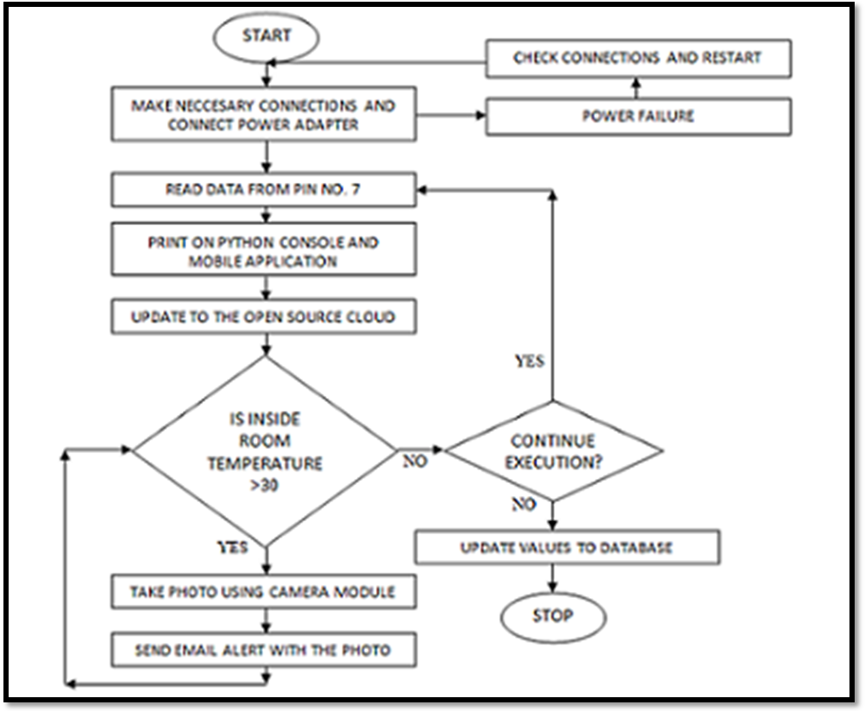

**Figure 5** Pictorial Representation of Algorithm

**5.2 Architecture Design**

**System Architecture:** A **system architecture** or **systems architecture** is the conceptual model that defines the structure, behavior, and more views of a system. An architecture description is a formal description and representation of a system, organized in a way that supports reasoning about the structures and behaviors of the system.

System architecture can comprise system components, the externally visible properties of those components, the relationships (e.g. the behavior) between them. It can provide a plan from which products can be procured, and systems developed, that will work together to implement the overall system.

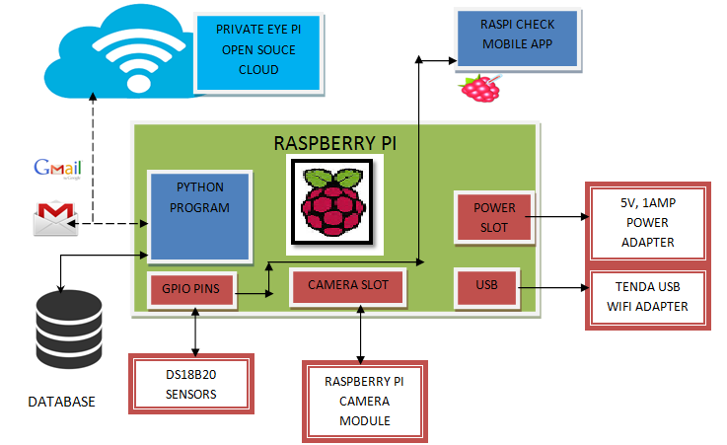

**Figure 6** System Design

**5.3 GRAPHICAL USER INTERFACE**

There are different interfaces provided to the user. One of them is the web user interface which is shown in figure 8. Another interface for the user is provided using mobile applications both on Android and IOS which are shown in figure 9 and 10.

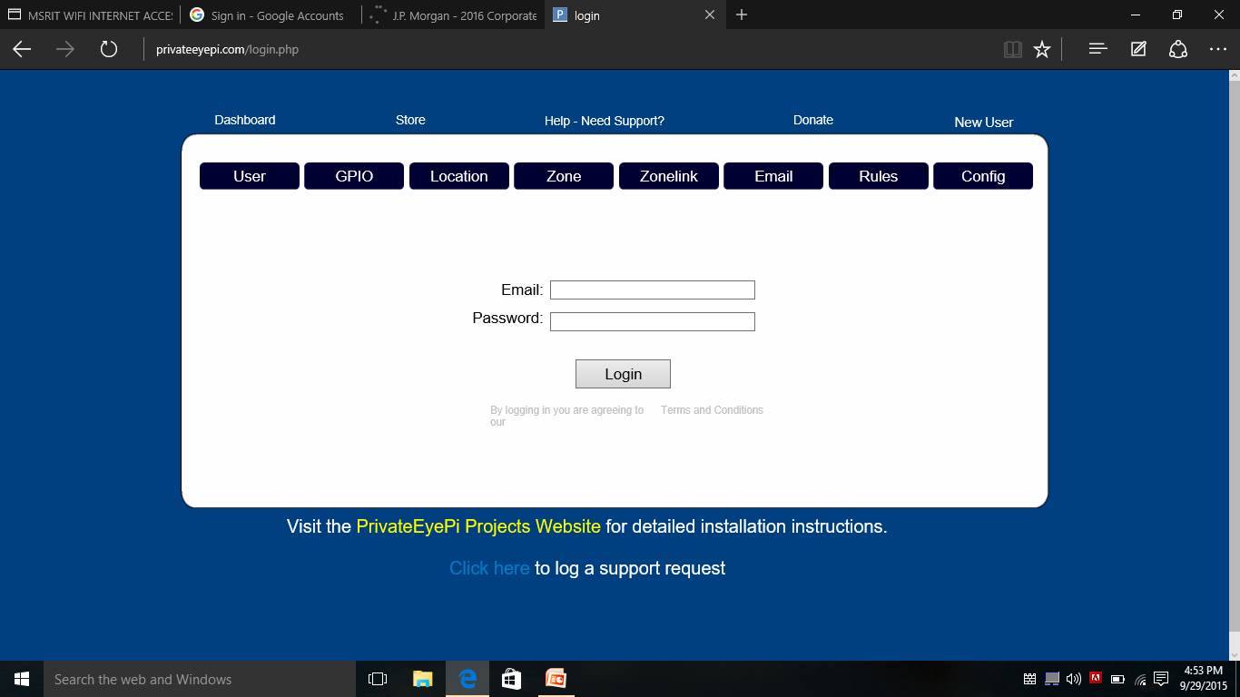

**Figure 7** Web GUI

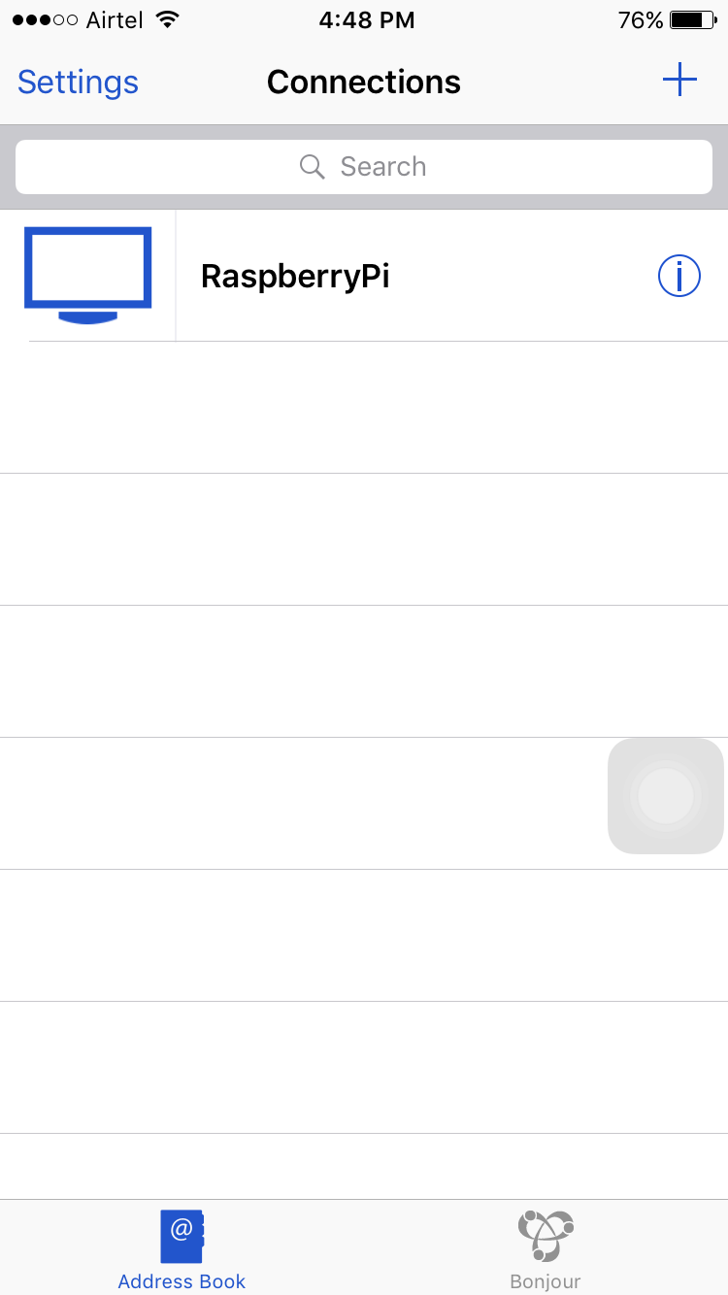

**Figure 8** IOS GUI

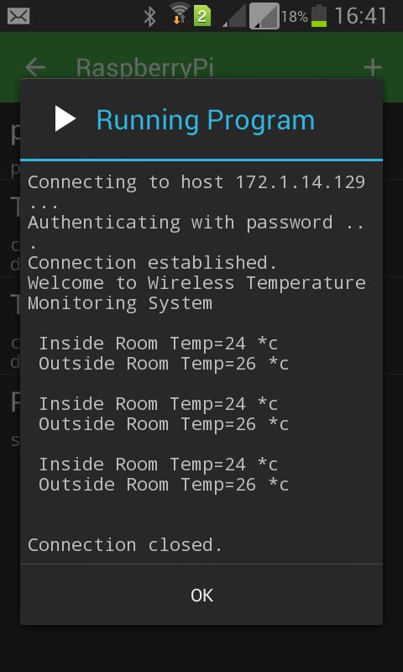

**Figure 9** Android GUI

**5.4 CLASS DIAGRAM**

* In software engineering, a class diagram in the Unified Modelling Language (UML) is a type of static structure diagram that describes the structure of a system by showing the system's classes, their attributes, operations (or methods), and the relationships among objects.
* The figure in the next slide represents the class diagram for wireless temperature monitoring system which uses association, aggregation, composition and generalization and many more features of the class model.
* The relationship among various classes and their interdependencies are effectively modeled using the class diagram.
* A class diagram is static in nature because it doesn’t represent the sequence of activities and also doesn’t bother about how system’s behavior varies from time to time due to uncertainties.

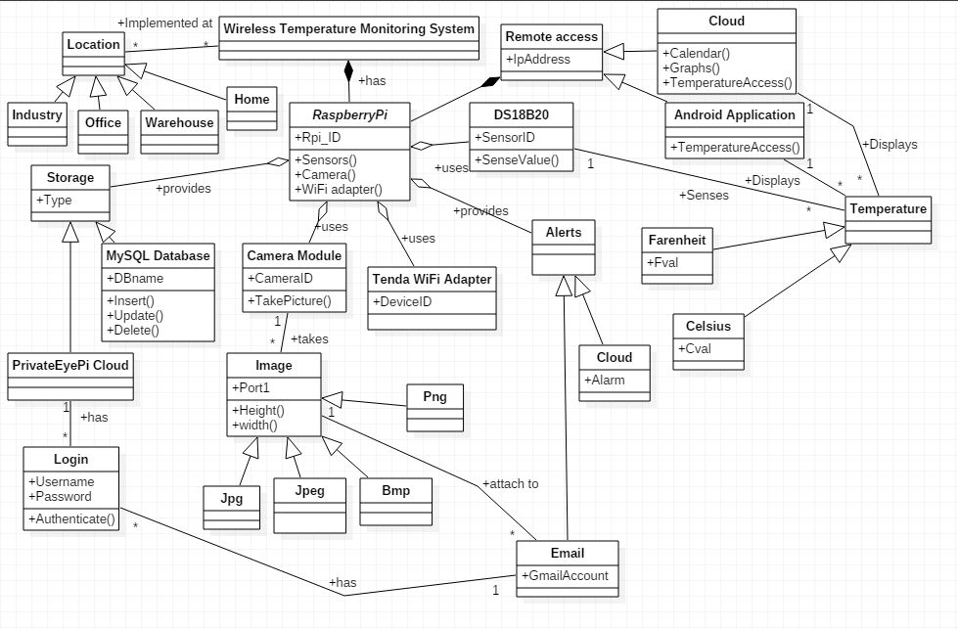

**Figure 10** Class diagram for wireless temperature monitoring system

**5.5 SEQUENCE DIAGRAM**

**Sequence diagram** is an interaction diagram that shows how processes operate with one another and in what order. It is a construct of a Message Sequence Chart. A sequence diagram shows object interactions arranged in time sequence. It depicts the objects and classes involved in the scenario and the sequence of messages exchanged between the objects needed to carry out the functionality of the scenario. Sequence diagrams are typically associated with use case realizations in the Logical View of the system under development. Sequence diagrams are sometimes called **event diagrams** or **event scenarios**.

A sequence diagram shows, as parallel vertical lines (*lifelines*), different processes or objects that live simultaneously, and, as horizontal arrows, the messages exchanged between them, in the order in which they occur. This allows the specification of simple runtime scenarios in a graphical manner. The sequence diagrams for wireless temperature monitoring system are

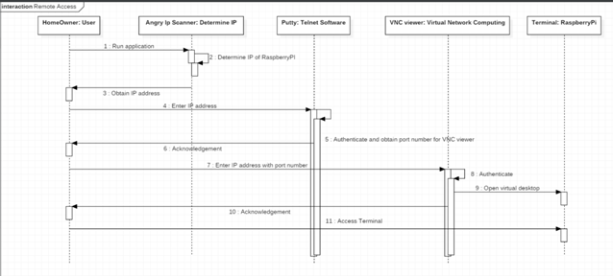

Figure 11 Sequence Diagram for Remote Access

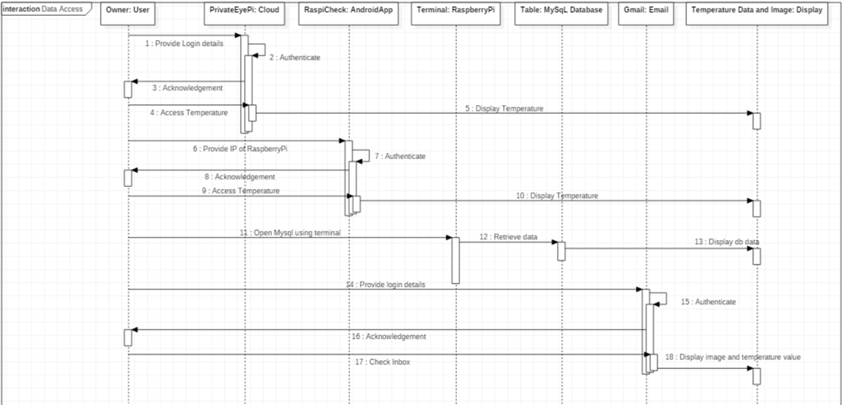

Figure 12 Sequence Diagram for Data Access

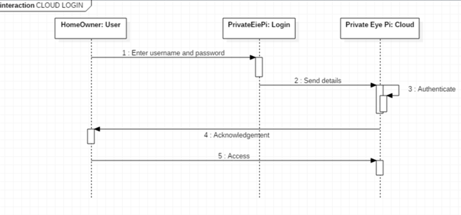

Figure 13 Sequence Diagram for Cloud Login

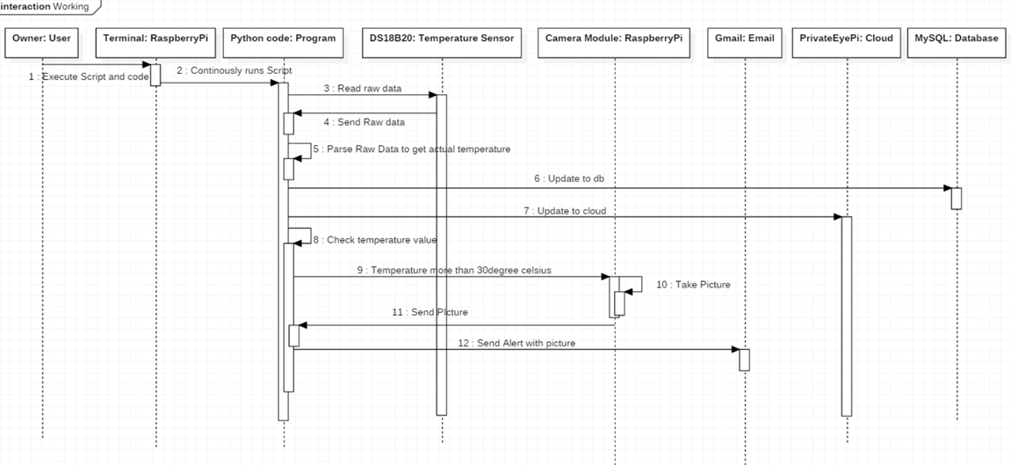

Figure 14 Sequence Diagram for Working

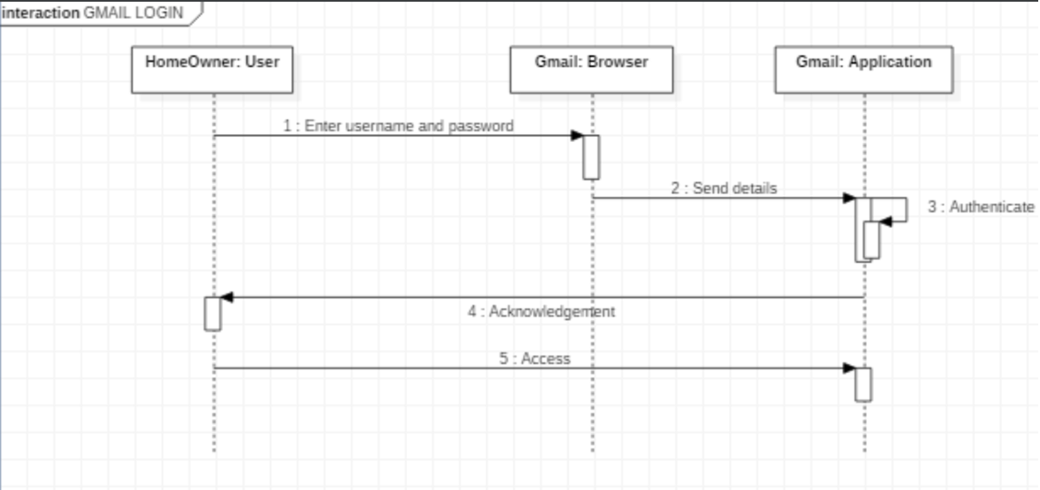

Figure 15 Sequence Diagram for Gmail Login

**5.6 Data Flow Diagram**

A **data flow diagram** (**DFD**) is a graphical representation of the "flow" of data through an information system, modeling its processaspects. A DFD is often used as a preliminary step to create an overview of the system, which can later be elaborated. DFDs can also be used for the visualization of data processing (structured design).

A DFD shows what kind of information will be input to and output from the system, where the data will come from and go to, and where the data will be stored. It does not show information about the timing of process or information about whether processes will operate in sequence or in parallel (which is shown on a flowchart).

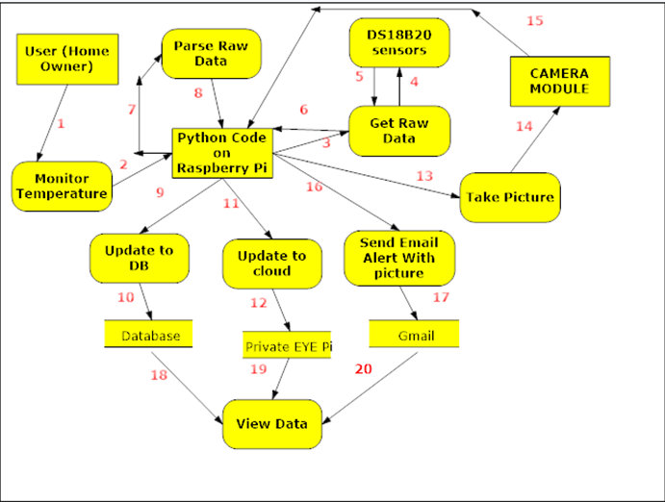

**Figure 16** Data Flow Model with numbers indicating the flow sequence

**5.7 METRIC CALCULATIONS**

There is a way to provide a project management status report. As an analogy, think about the criteria that a doctor might use to monitor health. He or she checks pulse, temperature, blood pressure etc. Similarly, a project needs to measure a mix of criteria.

If you distil the ground covered in methodologies and literature on Project Management, there are six criteria that constantly emerge. They are:

* + Time (How are we going against schedule)
  + Cost (How are we going against budget)
  + Resources (How much time are we spending on the project)
  + Scope (Is the scope creep in line with expectations)
  + Quality (Are we reviewing and fixing quality problems)
  + Actions (Do we have action items outstanding)

By looking at the performance against these six criteria as a project dashboard, a view of the parts of the project that are OK and the parts that are not OK can be formed.

Figure 4 gives the project’s timeline which specifies how time could be used in building in the project

Also the budget of the project has been estimated to be **Rs. 5000** as RaspberryPi2 costs around Rs. 2800.

The most common tool for managing a project is the schedule. Are we on time? At any point in a large project, there will probably be one or two tasks behind schedule and an equal number ahead of schedule.

It is not sensible to monitor budget in total. If the budget were spent half way through a project, we would suddenly be in trouble with no warning that the problem was occurring. For this reason, we need to create a project cash flow for the budget. Typically this is our estimate month by month of expenditure.

Just as we have a cash flow for money, we can do a project human resource projection. To do this we need to estimate how many man-days per period will be used on the project. By comparing that to timesheets, we can work out if we are spending more or less time on the project than estimated.

Every project will have some scope changes. A weakness in most project scope management is that scope changes are not monitored. Approval is often verbal and not recorded.

A better way is to admit the blindingly obvious at the planning stage - there will be scope changes, and we need to allow for them. The next step is to put in place a tracking system with approvals. At the start of the project, estimate how much scope increases are likely to be as a percentage of the estimated budget, and as each increase is approved, monitor the total scope creep.

One way to monitor quality is to set up a quality assurance project plan with quality events at the planning stage. These are activities that can be undertaken to check quality such as a walkthrough, or an inspection of a document, or testing of a particular component. As each of these events is completed, we can list action items flowing from the activity.

**6. IMPLEMENTATION**

**6.1 TOOLS INTRODUCTION**

|  |
| --- |
|  |

**Figure 17** Tools Required

All the hardware requirements that are needed to implement wireless temperature monitoring system are given in figure 19.These include a 64b micro SD card which is of class 10 or higher, two DS18B20 sensors, 4.7ohm resistor, jumper wires, HDMI-VA adapter, 5volt power adapter, RJ45 LAN cable, Tenda Wi-Fi adapter, and Raspberry Pi Camera Module.

Certain components like monitor, keyboard and mouse are needed only for the initial phase of loading Raspbian OS. Later the RaspberryPi can be run headless by remotely accessing it by using applications like Putty and VNC viewer.

The Raspberry Pi camera module can be used to take high-definition video, as well as stills photographs.

Two DS18B20 sensors are used in this project. This semiconductor temperature sensor offers high accuracy and high linearity over an operating range of about 55 degree centigrade to 150 degree centigrade. It is an integrated circuit, and can therefore include extensive signal processing circuitry within the same package as the sensor thus eliminating additional circuitries. This sensor can be directly connected to the Raspberry pi’s GPIO pin and thus capable of direct and reliable communication with it. Other features are that it’s lightweight and has a wide power supply range (2.7 V to 5.5 V) and converts the temperature to a digital value in less than 1s.

**6.2 TECHNOLOGY INTRODUCTION**

* Various software applications are used namely
  + SD card Formatter to initially erase all the data on the SD card.
  + Angry IP scanner to detect the IP addresses of all devices connected to a Wi-Fi network.
  + Putty is a SSH telnet software which is used to remotely access the Raspbian OS’s terminal.
  + VNC viewer is used to access the virtualized Raspbian OS.
* Python is used for developing and writing the code to remotely access the raw temperature and parse it to obtain the actual temperature and also to send Gmail Alerts along with pictures of the surroundings if the temperature exceeds the threshold value.
* MySQL database for offline persistent storage.
* PrivateEyePi open source cloud.
* RaspiCheck Android application.

**6.3 IMPLEMENTATION VIEW**

The project’s overall implementation and working can be pictorially depicted with the help of a flowchart as shown in figure 20.

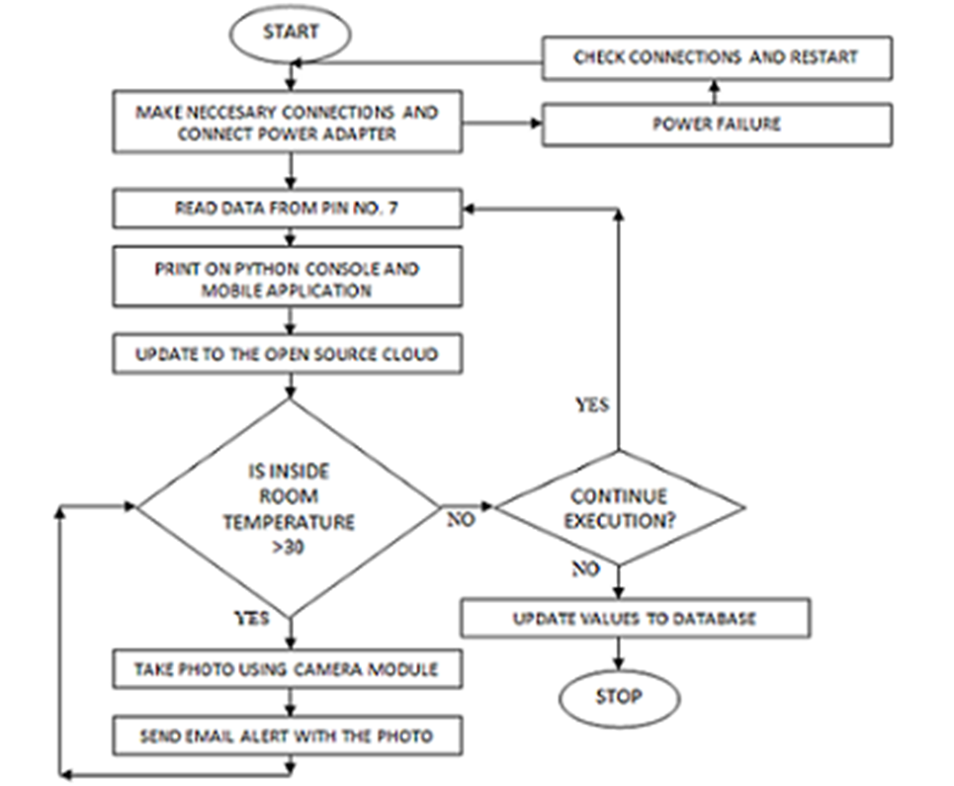

**Figure 18** Flowchart

**6.4 ALGORITHM**

Input: RaspberryPi with all the necessary connections.

Output: Updating Temperature values to cloud, database and sending Email Alert

1. Rd 🡨 Raw data from DS18B20sensors
2. P (Rd) // parsing the raw data to obtain the actual temperature values.
3. Update inside and outside room temperatures to the cloud.
4. While(InsideRt > 30 ) //InsideRt refers to inside room temperature

Img 🡨 Picture taken using raspberry pi camera module

Send Email Alert with Img as attachment

1. Update temperature values to database.
2. Loop back to step 1



**Figure 19** Algorithm Description

**6.5 MODULES**

The different modules needed and their description for the wireless temperature monitoring system are given below

**Remote Temperature Measurement Module**: This module is responsible for retrieving the raw data from the DS18B20 sensors and parses it to obtain the actual temperature and the temperature can be accessed remotely using Putty and VNCviewer.

**Camera Module**: This module is responsible to interfacing with the raspberry pi camera module and to take a picture of the surroundings when the room temperature exceeds the threshold value.

**Database Module**: This module’s function is to update the data into the backend MySQL database using python code.

**Cloud Module**: This module’s function is to update the temperature values into the cloud so that it can be accessible anywhere

**Email Module**: This module’s function is to send an Email alert to the intended recipient’s Gmail account if the temperature exceeds the predefined value using python code.

**Mobile App Module**: This module’s function is to remotely connect to the raspberry pi and determine the current inside and outside room temperature using RaspiCheck Android Application.

* **Remote Temperature Measurement Module :**

Output: Actual inside and outside room temperature of surroundings

Input: Raspberry Pi Board with necessary connections

Step 1) Obtain the raw data from the two DS18B20 sensors.

Step 2) Parse this raw data and convert it into Actual Temperature using necessary formula.

* **Cloud Module :**

Input: Actual inside and outside room temperature of surroundings

Output: Successfully updating it to PrivateEyePi

Step 1) **Front End Configuration**- Register an account in PrivateEyePi and enter necessary information.

Step 2) **Back End Configuration**- Download the install.sh file from PrivateEyePi.

Step 3) Modify globals.py file

Step 4) Run dallas.py

* **Email and Camera Module** :

Input: Intended recipients’ username and password

Output: Successfully sending mails with photo attachment

Step 1) Determine if inside room temperature is greater than 30 degree Celsius.

Step 2) If so, take a picture of the surroundings.

Step 3) Send a mail using python code with the photo as an attachment.

* **Database Module** :

Input: Actual inside and outside room temperature values

Output: Successfully committing the data to the database

Step 1) Write python code to insert new temperature values into the database along with the DS18B20 sensors’ unique identifier and the time of temperature reading.

Step 2) Use real time processing to make sure that the data is successfully committed to the database.

* **Mobile Module** :

Input: Raspberry Pi’s IP address

Output: Displaying temperature values on an android phone

Step 1) Use the IP scanner software to determine the IP address of raspberry pi.

Step 2) Display the temperature values on the phone by remotely running the script from the phone.

**SOURCE CODE**

import time

import smtplib

import MySQLdb

import picamera

from email.MIMEMultipart import MIMEMultipart

from email.MIMEText import MIMEText

from email.MIMEImage import MIMEImage

import base64

DS18B20_1="/sys/bus/w1/devices/28-031462453fff/w1_slave"

DS18B20_2="/sys/bus/w1/devices/28-04146467c8ff/w1_slave"

print("Welcome to Wireless Temperature Monitoring System\n")

i=0

while i<3:

first=open(DS18B20_1,"r")

data1=first.read()

first.close()

second=open(DS18B20_2,"r")

data2=second.read()

second.close()

(discard,sep,reading1)=data1.partition('t=')

(discard,sep,reading2)=data2.partition('t=')

t1=float(reading1)/1000

t2=float(reading2)/1000

r1=int(t1)

r2=int(t2)

print(" Inside Room Temp="+str(r1)+" *c")

print(" Outside Room Temp="+str(r2)+" *c\n")

if(r2>25):

print 'capturing...'

with picamera.PiCamera() as camera:

camera.start_preview()

time.sleep(3)

camera.capture('image.jpg')

camera.stop_preview()

print "Done"

strFrom = 'reloadp52@gmail.com'

strTo = 'vigneshp8080@gmail.com'

msgRoot = MIMEMultipart('related')

msgRoot['Subject'] = 'test message'

msgRoot['From'] = strFrom

msgRoot['To'] = strTo

msgRoot.preamble = 'This is a multi-part message in MIME format.'

msgAlternative = MIMEMultipart('alternative')

msgRoot.attach(msgAlternative)

msgText = MIMEText('This is the alternative plain text message.')

msgAlternative.attach(msgText)

msgText = MIMEText('<b>Inside room temperature is high</b>Check image<br><img src="cid:image1"><br>', 'html')

msgAlternative.attach(msgText)

fp = open('image.jpg', 'rb')

msgImage = MIMEImage(fp.read())

fp.close()

msgImage.add_header('Content-ID', '<image1>')

msgRoot.attach(msgImage)

u='reloadp52@gmail.com'

p='mynameisvigneshP'

smtp = smtplib.SMTP('smtp.gmail.com:587')

smtp.starttls()

smtp.login(u,p)

smtp.sendmail(strFrom, strTo, msgRoot.as_string())

smtp.quit()

time.sleep(2)

i=i+1

db=MySQLdb.connect("localhost","monitor","pi","temps")

curs=db.cursor()

with db:

curs.execute("Insert into tempdat values(CURRENT_DATE(),NOW(),'home',\""+str(r1)+"\",'28-031462453fff')")

curs.execute("Insert into tempdat values(CURRENT_DATE(),NOW(),'home',\""+str(r2)+"\",'28-04146467c8ff')")

print "Data committed"

curs.execute("select *from tempdat");

print"Wireless Temperature Monitoring Database System"

print"\nDate Time Location Temperature SensorId"

print"*******************************************************************************************"

for reading in curs.fetchall():

print str(reading[0])+" "+str(reading[1])+" "+str(reading[2])+" "+str(reading[3])+" "+str(reading[4])

print"*******************************************************************************************"

db.close()

**7. TESTING**

**7.1 Results and Snapshots**

Configure raspberry pi by loading NOOBS.

* Identify sensors using Linux commands
* **sudo modprobe w1-gpio**
* **sudo modprobe w1-therm**
* **Cd /sys/bus/w1/devices**
* We found the sensor ids to be **28_031462453fff** and **28_04146467c8ff**
* The raw temperature can be obtained by using the following commandsshown in the diagram given in the next slide.
* Then the raspberry pi is remotely accessed using angry IP scanner and Putty.
* Later VNC viewer is used to access the Raspbian OS’s GUI.

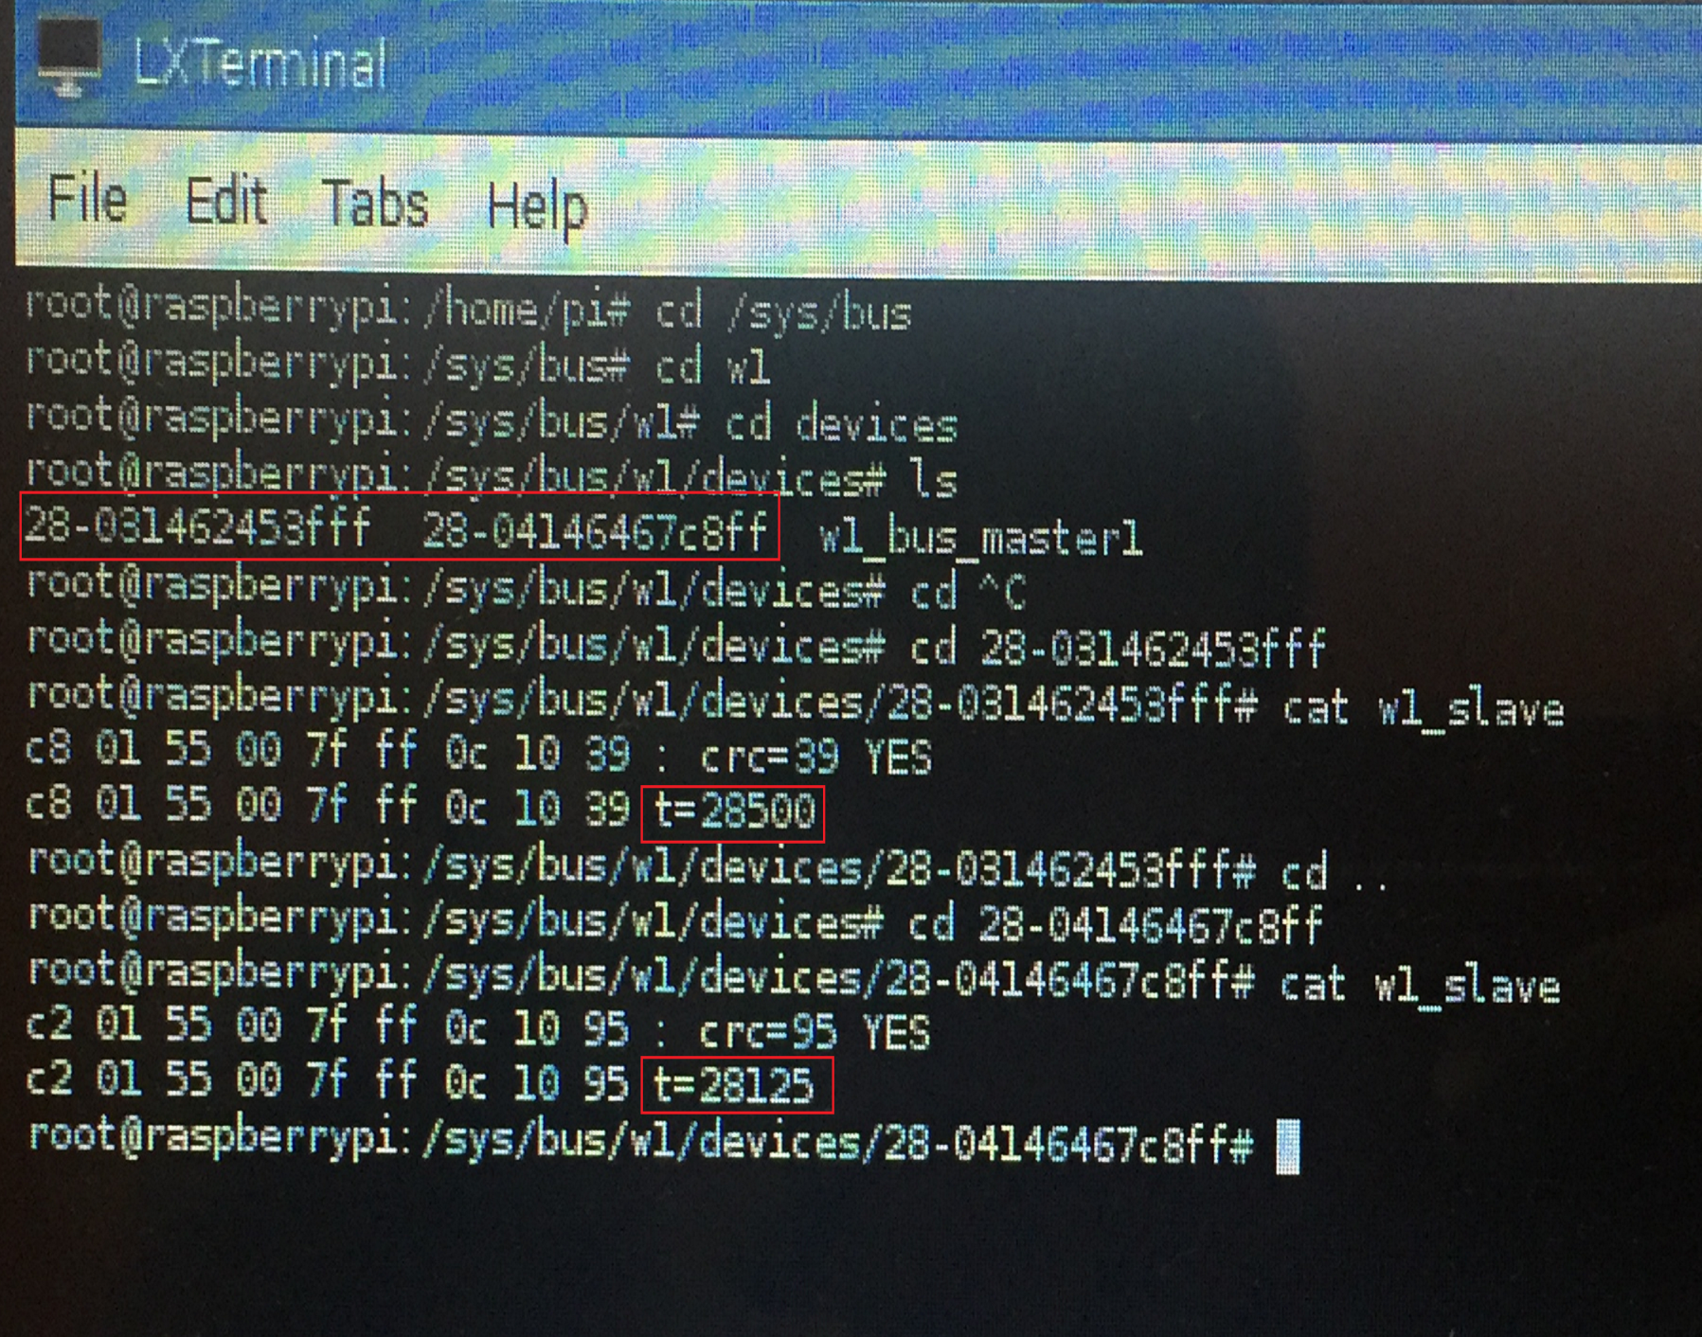

**Figure 20** Terminal Access

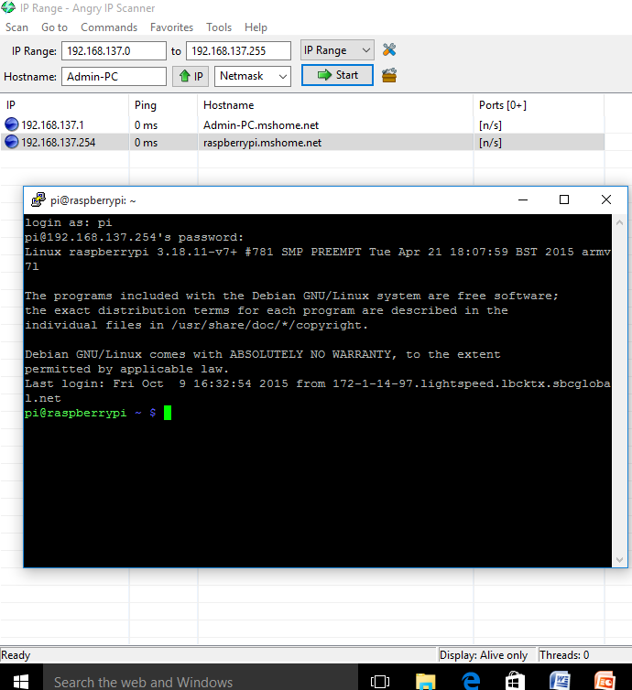

**Figure 21** Angry IP Scanner and Putty

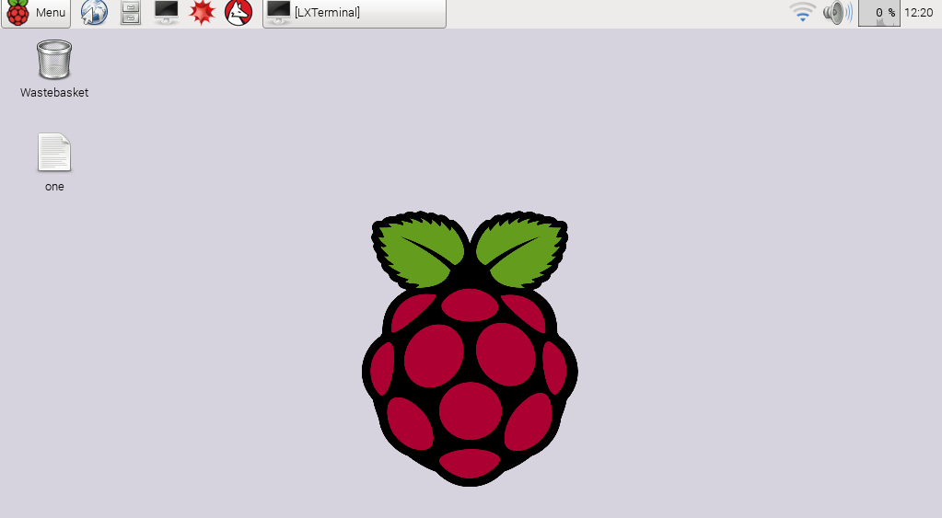

**Figure 22** VNCviewer

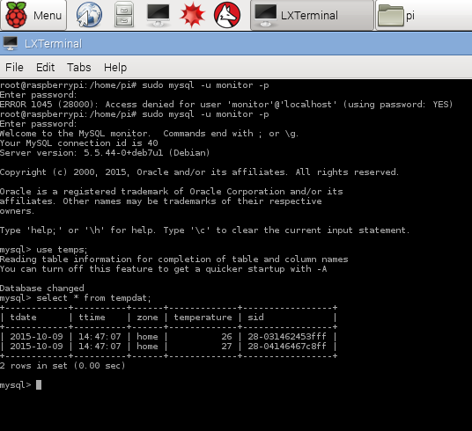

**Figure 23** Database Access

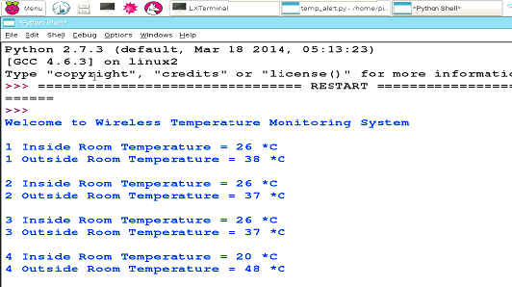

**Figure 24** Console View

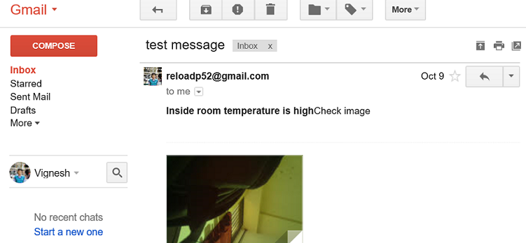

**Figure 25** Gmail Alert



**Figure 26** Cloud Login

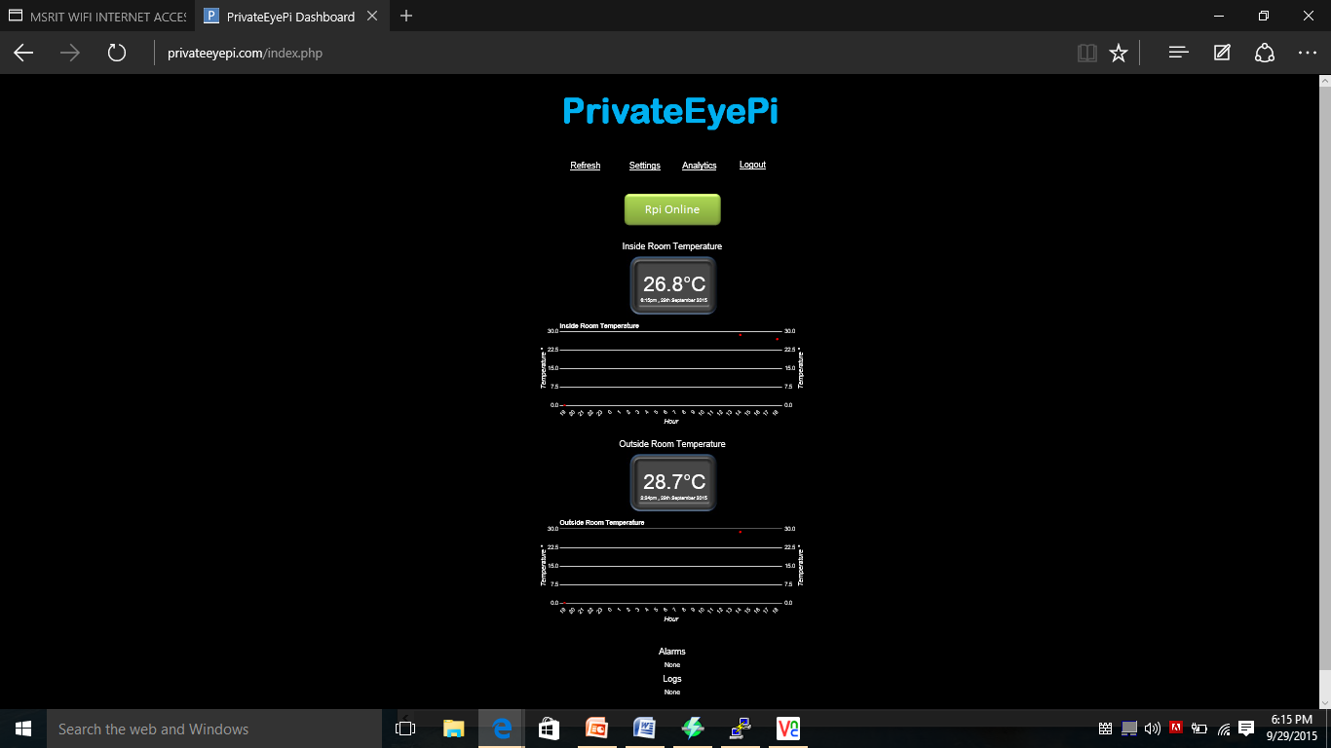

**Figure 27** Cloud Access Screen

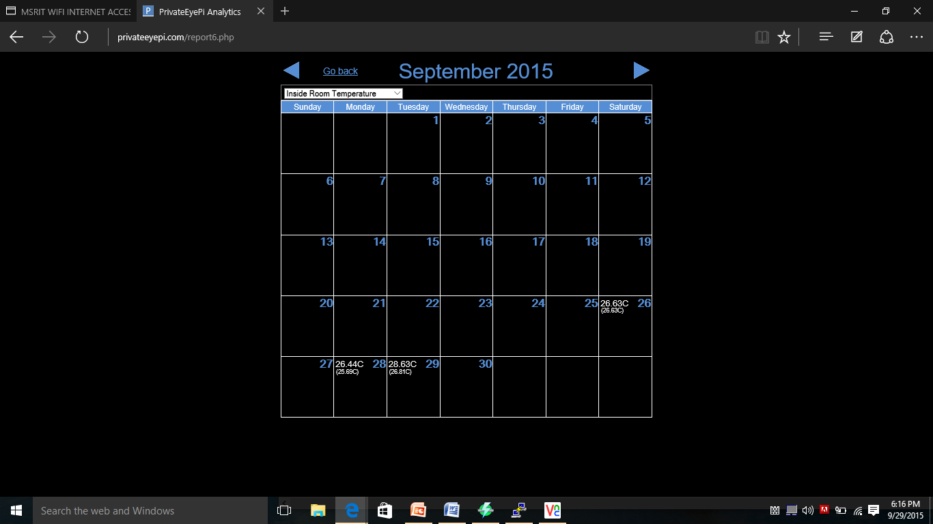

**Figure 28** Calendar on cloud (Inside Room Temperature)

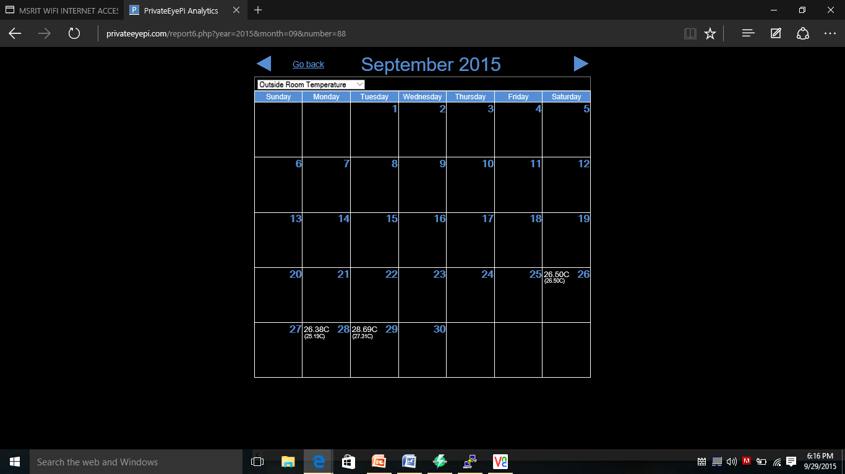

**Figure 29** Calendar on cloud (Outside Room Temperature)

**8. CONCLUSION AND SCOPE FOR FUTURE WORK**

Thus we have designed a wireless temperature monitoring system that is capable of remotely measuring the temperature and updating the values to the cloud and database and also send Gmail alerts along with pictures when the temperature exceeds the user defined limit.

All of the objectives of the project have been successfully completed and the desired results have been obtained.

We would like to extend this project by examining or analyzing the effectiveness and the responsiveness of the open source cloud and to find out ways to improve them. Mobile notifications and Amazon Web Services’ SNS (Simple notification service) can be integrated to the wireless temperature monitoring system in order to have a much broader scope and range in terms of the notifications that are sent to the intended recipients apart from the Gmail alerts, cloud updates and database updates.

**9. REFERENCES**

The following online links were used

* <https://en.wikipedia.org/wiki/Wiki>
* <https://www.raspberrypi.org/>
* <http://www.projects.privateeyepi.com/home/temperature-gauge>
* <http://www.element14.com/community/thread/34969/l/wireless-monitoring-system-using-raspberry-pi?displayFullThread=true>
* <http://www.slideshare.net/KrishnaKumar272/smart-wireless-surveillance-monitoring-using-raspberry-pi>
* <http://datasheets.maximintegrated.com/en/ds/DS18B20.pdf>

The following books were very helpful

* Raspberry Pi User Guide by Eben Upton and [Gareth Halfacree](http://www.amazon.com/Gareth-Halfacree/e/B0088CA5ZM/ref=sr_ntt_srch_lnk_1?qid=1449728684&sr=1-1).
* Raspberry Pi Projects for the Evil Genius by [Donald Norris](http://www.amazon.com/Donald-Norris/e/B00FRYI2GI/ref=sr_ntt_srch_lnk_2?qid=1449728684&sr=1-2).
* Shan and M. Richardson Getting *Started with Raspberry pi*, 2012 :O'Reilly Media, Inc